Lab 2: Snapshot feature in Oracle VirtualBox

Theory
A snapshot in Oracle VirtualBox is a feature that allows users to capture the exact state of a virtual machine (VM) at a specific point in time. This state includes the VM’s operating system, installed software, memory state, and system settings. Snapshots are useful for testing software, experimenting with system configurations, and learning environments because they allow users to revert back to a previous working state if something goes wrong.
Snapshots help in:
- Safe experimentation without risk of permanent damage
- Quick recovery from errors or system crashes
- Maintaining multiple system states for testing and learning

Steps:
- Open the terminal and ubuntu and make some directories and files using commands accordingly.

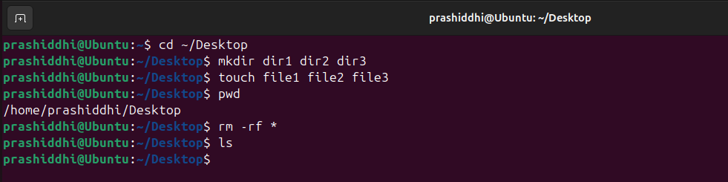

- After shutting down the virtual machine, click on the snapshots section in virtualbox manager > take snapshot and add name, description for it.

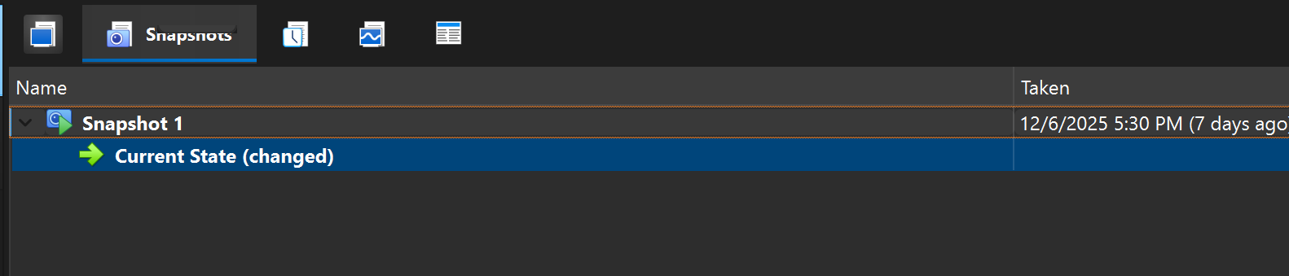

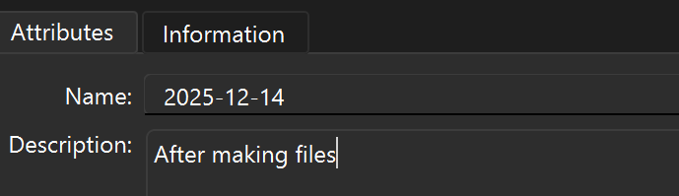

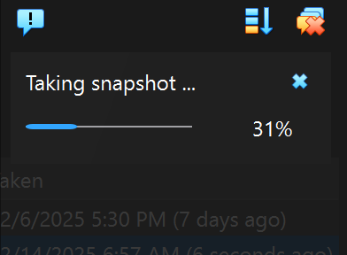

- Now, start the virtual machine again and delete all the previously created files and directories. Confirm the deletion using ls.

- Power off the virtual machine again, select the saved snapshot and click on Restore.

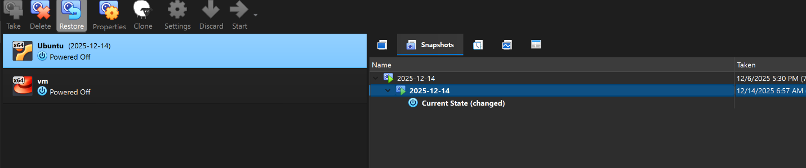

- Once restoration is done successfully, again turn on the virtual machine and verify if the files deleted previously have also been restored or not.

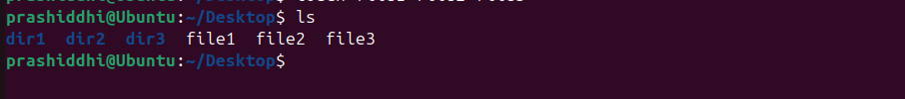

Result and Conclusion:

Result: The snapshot of the Ubuntu virtual machine was successfully created after creating files and directories using the terminal. When all the files and directories were deleted and the snapshot was restored, the virtual machine returned to its previous state. The deleted files and directories were visible again, proving that the snapshot restoration worked correctly.

Conclusion: The snapshot feature in Oracle VirtualBox was studied and implemented successfully. By creating files, deleting them, and then restoring a snapshot, it was observed that the virtual machine can be reverted to an earlier state without any data loss. This feature is very useful for testing, learning, and experimentation, as it allows users to safely undo mistakes and recover the system to a stable condition.

